–––

|  |  |  |  |
| --- | --- | --- | --- |
| Angol szóbeli vizsga | Középszint | 1.Vizsgafeladat | Bevezető interjú |

**1. Vizsgafeladat -vizsgáztatói példány**

**Bevezetés (nem értékeljük)**

Mielőtt a tényleges szóbeli vizsga elkezdődik, egy rövid (kb. egyperces) bemelegítő beszélgetés szükséges.

Vizsgáztató:

* Did you sleep well?
* How are you today?
* What did you do yesterday evening?
* When did you get up?
* Is it the first time you are taking an exam?
* How did you come here?
* Are you planning to have a party after the exam?
* ( If “no”: ) What are you going to do after the exam?

Now I am going to ask you a few questions. If you can’t understand me, I can repeat the question once. Let’s get started.

**Tényleges vizsga (ettől a résztől értékeljük):**

Vizsgáztató:

We are going to talk about your place of living.

A What can you tell me about Hungary?

**Hungary is (situated) in the Middle of Europe. It’s a small country, its population is about 9 million people. The capital city is Budapest. The two longest rivers are the River Danube and the River Tisza. The highest mountain peak is Kékestető. The biggest towns are: Debrecen, Miskolc…The biggest lake is Lake Balaton. My favourite place in Hungary is…**

B Tell me some information about the place where you live e.g., location, population. What is your town/village famous for?

**I live in Dombóvár. It’s a small town in Tolna county with about 18,000 inhabitants. Dombóvár is famous for Gunaras spa and Peace Park. A lot of foreign tourists visit Gunaras Spa every year. You can go swimming and sunbathe there. You can find the statues of famous Hungarian politicians in Peace Park. You can also do some sports there, for example running or tennis.**

C What are the places you can go out in your town/village?

**You can go to different restaurants, for example….**

**My favourite place is…**

**I meet my friends…**

Thank you very much.

That’s the end of your first task.

|  |  |  |  |
| --- | --- | --- | --- |
| Angol szóbeli vizsga | Középszint | 2.Vizsgafeladat | Szituációs feladat |

# 2. Vizsgafeladat - vizsgáztatói példány

A vizsgáztató átadja a vizsgázónak a vizsgázó feladatlapját. A vizsgázó kb. fél percig készülhet.

A vizsgázó példánya

You want to go on holiday to a seaside resort in Italy with one of your friends. Discuss which means of transport to use. Include the following points:

- advantages/disadvantages of each

- buying tickets

- activities you can do during the journey

- your experience

**Prompts for the interlocutor:**

* Now we should plan our journey to Italy. Which means of transport should we choose?
* **I think we should travel by train.**
* What are the advantages?
* **It is cheaper than travelling by plane. You can move on the train.**
* What are the disadvantages?
* **It’s slower than the plane, the journey is long and tiring.**
* Where can we buy the tickets?
* **I’ll buy the tickets on the Internet.**
* What can we do during the journey?
* **Since the journey is long, we can watch a movie, listen to music and talk a lot.**
* Have you ever travelled by train abroad?
* **No, I haven’t, but I hope we will enjoy the journey.**
* I hope so.

Melléklet: 2.1 kép

**2.1**

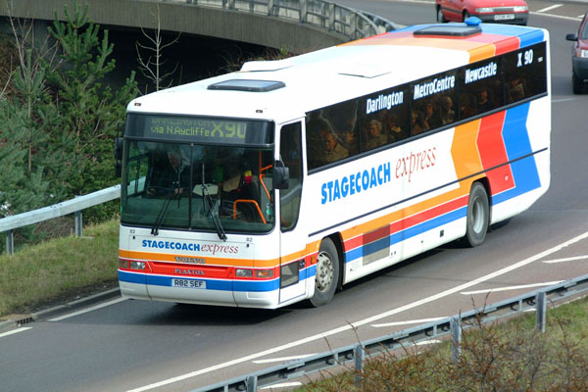

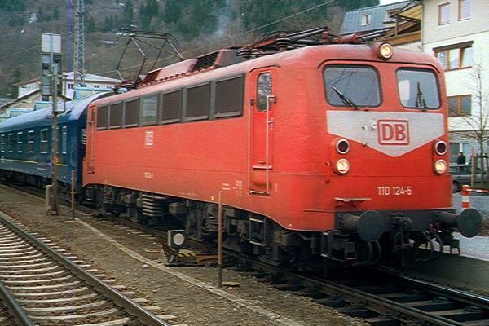

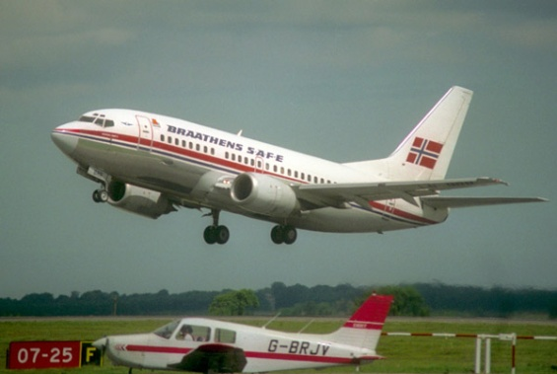

|  |  |  |  |
| --- | --- | --- | --- |
| Angol szóbeli vizsga | Középszint | 3.Vizsgafeladat | Önálló témakifejtés |

#### **3. Vizsgafeladat - vizsgáztatói példány**

A vizsgáztató átadja a vizsgázónak a vizsgázó feladatlapját. A vizsgázó kb. fél percig készülhet.

# A vizsgázó példánya

Tell us about the differences between traditional dishes and junk food. Describe the different types of restaurants. Include the following points:

- healthy diet

- your favourite breakfast/lunch

- traditional Hungarian dishes

- possibilities for eating out

**In the first picture I can see some typical English food. In the second picture I can see a hamburger. English food is healthy, hamburger is unhealthy.**

**Healthy diet means a lot of fruit and vegetables. If you want to live a healthy life, you shouldn’t eat a lot of sweets and fat food or drink alcohol.**

**My favourite food is…My mother makes it…I can make it… The ingredients are…**

**I can cook./I can’t cook. In my family my mother cooks…My speciality is...**

**In Dombóvár there are many restaurants (….) where you can have lunch or dinner. My favourite restaurant is…**

**THANK YOU, THIS IS THE END OF YOUR EXAMINATION.**

Melléklet: 3.1

**K 3.1**

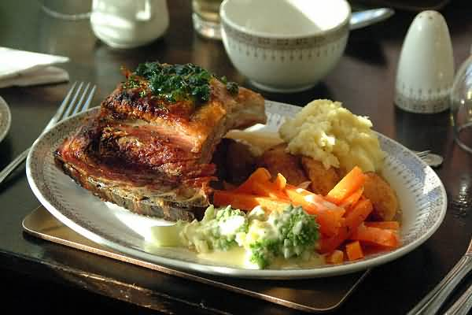

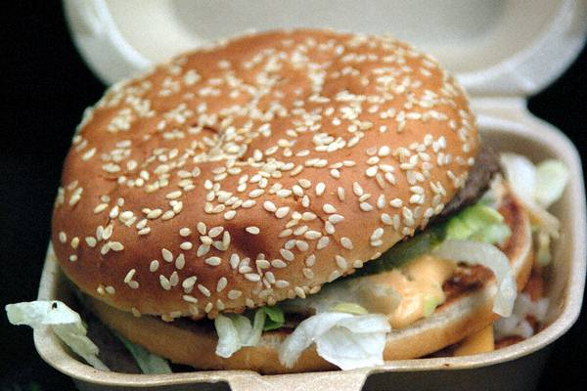

|  |  |  |  |
| --- | --- | --- | --- |
| Angol szóbeli vizsga | Középszint | 2.Vizsgafeladat | Szituációs feladat |

# 2. Vizsgafeladat - vizsgázói példány

A vizsgázó példánya

You want to go on holiday to a seaside resort in Italy with one of your friends. Discuss which means of transport to use. Include the following points:

- advantages/disadvantages of each

- buying tickets

- activities you can do during the journey

- your experience





|  |  |  |  |
| --- | --- | --- | --- |
| Angol szóbeli vizsga | Középszint | 3.Vizsgafeladat | Önálló témakifejtés |

#### **3. Vizsgafeladat - vizsgázói példány**

# A vizsgázó példánya

Tell us about the differences between traditional dishes and junk food. Describe the different types of restaurants. Include the following points:

- healthy diet

- your favourite breakfast/lunch

- traditional Hungarian dishes

- possibilities for eating out

